Software Requirement Specifications
Smart Scholarship System



Submitted by
Nazik Kareem (S23BINFT1M01127)

Submitted to
Mr. Umar Riaz

Department of Information Technology
Faculty of Computing
The Islamia University of Bahawalpur

Meeting Details
Sr No | Details | Date | Supervisor Signature
Summary
This document presents the Software Requirement Specification (SRS) for the Scholarship Management System. The system is designed to automate scholarship processes including student applications, document verification, donor funding, and intelligent student selection using machine learning. The system introduces a smart recommendation mechanism using the K-Nearest Neighbors algorithm to identify deserving students based on similarity with previously approved applicants. It ensures transparency, efficiency, and fairness in scholarship distribution.

Table of Contents
1. Introduction 5
1.1. Purpose 5
1.2. Scope 6
1.3. Product Perspective 6
1.4. User Characteristics 6
1.5. Similar apps and systems/Literature Review 7
1.6. Proposed Technologies 7
1.7 Machine learning integration 7
2. Requirements 8
2.1. Function Requirements 8
2.1.1. Sign Up 8
2.1.2. Login 8
2.1.3. Forget password 9
2.1.4. Apply for Scholarship 9
2.1.5. Upload documents 9
2.1.6. View status 9
2.1.7. Verify applications 10
2.1.8. Manage Scholarships 10
2.1.9. Donor Registration 10
2.1.10. Provide Funding 10
2.1.11. Location-Based Matching 11
2.1.12. System filters students by area 11
2.1.13. Train KNN model 11
2.1.14. Predict eligible 11
2.1.15. Smart Recommendation 12
2.2. Non-Functional Requirements 12
3. Use Cases and Flow of Processes 12
3.1. Use Case 1 14
3.2. Use Case 2 15
3.3. Use Case 3 17
3.4. Use Case 4 18
3.5. Use Case 5 20
4. References 22

- Introduction
The Scholarship Management System is a web-based application designed to digitize and automate the scholarship process in educational institutions. Traditional manual systems are inefficient, slow, and lack transparency. This system provides a centralized platform where students can apply for scholarships, donors can fund students, and administrators can manage applications efficiently.
The system also introduces intelligent decision-making through machine learning, improving the fairness and accuracy of scholarship allocation.
  - Purpose
- Provide an online scholarship platform
- Automate application and verification
- Connect donors with deserving students
- Use machine learning for smart selection
- Improve transparency and efficiency
  - Scope
Included:
- Student, Admin, Donor registration
- Scholarship applications
- Document uploads
- Donor funding system
- Location-based matching
- ML-based recommendations
Not Included:
- Direct bank payment integration
- Mobile app (web only)
  - Product Perspective
The Scholarship Management System is a web-based standalone application designed to automate and manage the scholarship process. It follows a client-server architecture where the frontend interacts with the backend for processing and data management. The system can be integrated in the future with university databases or financial systems. It includes a machine learning component based on the K-Nearest Neighbors algorithm to recommend deserving students. The system is modular, allowing future enhancements such as mobile apps or payment integration. Overall, it is designed to be scalable, efficient, and user-friendly.
  - User Characteristics
Admin
- Manage users and scholarships
- Verify applications
- Train ML model
Student
- Register and apply
- Upload documents
- Track status
Donor
- Register and login
- Fund scholarships
- Select students manually or via recommendations
  - Similar apps and systems/Literature Review
Existing systems:
- Government scholarship portals
- University systems
Existing scholarship systems such as government portals and university-based platforms provide basic functionalities for application submission and processing. These systems mainly focus on managing large volumes of applications but often lack user-friendly interfaces and real-time tracking features. Most of them do not include donor participation, limiting external funding opportunities for students. Additionally, traditional systems rely on manual or rule-based selection processes, which may lead to inefficiencies and bias. The proposed system improves upon these by integrating automation, donor involvement, location-based matching, and intelligent decision-making.
  - Proposed Technologies
- Frontend: HTML, CSS, JavaScript
- Backend: Django (Python) Or Laravel
- Database: MySQL
- Machine Learning: Python (Scikit-learn)
- Tools: GitHub, VS Code

1.7 Machine learning integration

The system uses the K-Nearest Neighbors algorithm to recommend deserving students.
Working:
- Compares new student data with previous records
- Finds similar (nearest) students
- Predicts eligibility
Features Used:
- Academic performance
- Financial condition
- Location
- Previous approval history

- Requirements
Authors have to provide a brief of functions of the project. For example, if a Hospital Management System is going to develop and Patient and Doctor module is going to implement then patient admission, appointment system and billing can be described here. Authors will write these items in the form of paragraph without providing some title.
  - Function Requirements
    - Sign Up
- Name: FR001
- Purpose: Sign up is required to register a new user (Student, Admin, or Donor) in the system.
- User(s): Student, Admin, Donor
- Input:
- Name: Full name of user
- Email: Valid email address
- Password: Minimum 8 characters
- Phone: Valid phone number
- Output:
- User account is created and stored in the system
    - Login
- Name: FR002
- Purpose: Authenticate user before accessing system features.
- User(s): Student, Admin, Donor
- Input:
- Email: Registered email
- Password: Correct password
- Output:
- User is authenticated and redirected to dashboard
    - Forget password
- Name: FR003
- Purpose: Allow users to reset password.
- User(s): Student, Admin, Donor
- Input:
- Email: Registered email
- Output:
- Reset link/OTP sent to email
- User can create new password
    - Apply for Scholarship
- Name: FR004
- Purpose: Allow students to apply for scholarships.
- User(s): Student
- Input:
- Academic details
- Financial information
- Personal details
- Output:
- Application submitted successfully
    - Upload documents
- Name: FR005
- Purpose: Upload required documents for verification.
- User(s): Student
- Input:
- CNIC/B-Form
- Transcripts
- Income proof
- Output:
- Documents stored in system
    - View status
- Name: FR006
- Purpose: Allow students to track application status.
- User(s): Student
- Output:
- Status displayed (Pending / Approved / Rejected)
    - Verify applications
- Name: FR007
- Purpose: Admin verifies student applications.
- User(s): Admin
- Input:
- Student application data
- Output:
- Application approved or rejected
    - Manage Scholarships
- Name: FR008
- Purpose: Admin manages scholarship listings.
- User(s): Admin
- Input:
- Scholarship details
- Output:
- Scholarships created/updated
    - Donor Registration
- Name: FR009
- Purpose: Register donors in system.
- User(s): Donor
- Input:
- Name, Email, Password
- Address, City
- Output:
- Donor account created
    - Provide Funding
- Name: FR010
- Purpose: Donor provides funding.
- User(s): Donor
- Input:
- Amount
- Number of students
- Criteria
- Output:
- Scholarship funding created
    - Location-Based Matching
- Name: FR011
- Purpose: Match students with donors based on location.
- User(s): Donor, System
- Input:
- Donor location
- Student location data
- Output:
- Filtered student list
    - System filters students by area
- Name: FR012
- Purpose: Donor selects student for scholarship.
- User(s): Donor
- Input:
- Selected student profile
- Output:
- Scholarship assigned
    - Train KNN model
- Name: FR013
- Purpose: Train ML model for prediction.
- User(s): Admin/System
- Input:
- Historical student data
- Output:
- Trained model
    - Predict eligible
- Name: FR014
- Purpose: Predict deserving students using K-Nearest Neighbors algorithm
- User(s): System
- Input:
- Student application data
- Output:
- Eligibility prediction
    - Smart Recommendation
- Name: FR015
- Purpose: Recommend students to donors.
- User(s): Donor
- Input:
- Donor criteria
- Output:
- Recommended students list
  - Non-Functional Requirements
- User-friendly interface
- Fast response (<3 seconds)
- Secure authentication
- Data privacy
- 24/7 availability
- Backup system
- Accurate ML predictions

- Use Cases and Flow of Processes
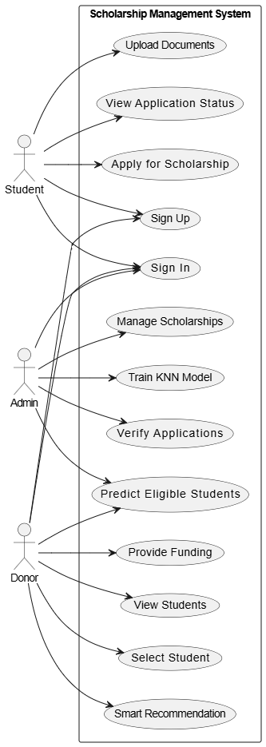
  - Use Case 1
Field | Details
ID | UC001
Name | Sign In
Description | This use case describes the process flow of signing in for a registered user (Student/Admin/Donor).
Requirement(s) | FR001
Actor(s) | Student, Admin, Donor
Precondition | Actor must have a registered account and an internet connection.
Postcondition | Actor is authenticated successfully and redirected to the dashboard.
Basic Flow
- Actor opens the web application.
- System displays the Sign In page.
- Actor enters credentials.
3.1 Following fields are required:
3.1.1 Email
3.1.2 Password
- System validates the input.
4.1 System checks proper inputs for the following:
4.1.1 Email format must be valid
4.1.2 Password length must be at least 8 characters
- Actor clicks “Sign In”.
- System sends credentials to the backend server.
- System verifies the credentials.
- System creates an authenticated session.
- System redirects the actor to the dashboard.
Alternative Flow
- Actor clicks “Forgot Password”.
- System asks for the registered email.
- Actor enters email.
- System sends a reset link/OTP to the actor.
- Actor resets password and logs in again using the Sign In process.
Exceptions
- E1: Invalid Input — System shows an error for invalid email format or invalid password length.
- E2: Authentication Failed — System shows “Invalid email or password”.
- E3: Network Error — System shows a connection/network error message.
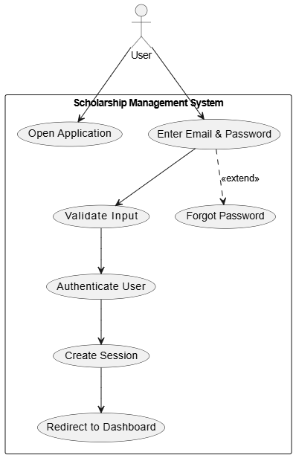
  - Use Case 2
Field | Details
ID | UC002
Name | Apply for Scholarship
Description | This use case describes how a student applies for a scholarship by filling out an application form and submitting required documents.
Requirement(s) | FR002
Actor(s) | Student
Precondition | Student must be logged in.
Postcondition | Scholarship application is submitted successfully and stored in the database.
Basic Flow
- Student logs into the system.
- Student selects “Apply for Scholarship”.
- System displays the scholarship application form.
- Student enters the required details.
4.1 Academic details
4.2 Financial details
4.3 Personal information
- Student uploads required documents.
- Student submits the application.
- System validates the inputs.
- System stores the application in the database.
- System shows a confirmation message to the student.
Alternative Flow
- Student selects “Save Draft” instead of submitting the application.
- System saves the incomplete application as a draft.
- Student can return later to continue and submit.
Exceptions
- E1: Missing Fields — System highlights missing required fields and requests completion.
- E2: File Upload Error — System shows an upload failure message and asks the student to re-upload documents.
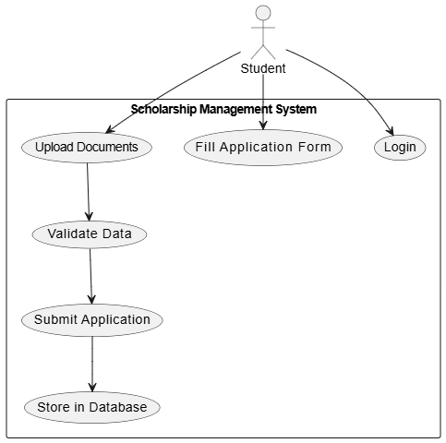
  - Use Case 3
Field | Details
ID | UC003
Name | Donor-Student Matching
Description | This use case describes how a donor searches for students based on selected criteria (e.g., location and funding criteria).
Requirement(s) | FR003
Actor(s) | Donor
Precondition | Donor must be logged in.
Postcondition | A list of matching students is displayed to the donor.
Basic Flow
- Donor logs into the system.
- Donor selects “Find Students”.
- Donor enters matching criteria.
3.1 Location (city/area)
3.2 Funding criteria
- System processes the request.
- System filters students by location and criteria.
- System displays the list of matching students.
Alternative Flow
- Admin assigns students manually to a donor (instead of donor searching).
- System updates the donor’s assigned/matched student list.
Exceptions
- E1: No Students Found — System shows “No matching students found”.
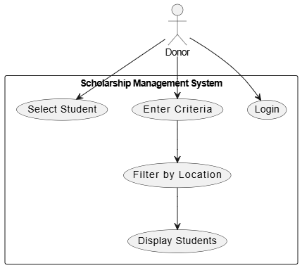
  - Use Case 4
Field | Details
ID | UC004
Name | Smart Recommendation (ML Based)
Description | This use case describes how the system recommends eligible students to a donor using a trained ML model (K-Nearest Neighbors).
Requirement(s) | FR004
Actor(s) | Donor, System
Precondition | Donor must be logged in and the ML model (KNN) must be trained with relevant data.
Postcondition | System displays a list of recommended students.
Basic Flow
- Donor logs into the system.
- Donor selects “Get Recommendations”.
- System collects donor criteria.
- System sends the criteria/data to the ML module.
- ML model analyzes student data using K-Nearest Neighbors.
- System predicts eligible students.
- System filters predicted students by location (if applicable).
- System displays recommended students to the donor.
Alternative Flow
- Donor selects students manually without using ML recommendations.
- System proceeds with donor’s manual selection workflow.
Exceptions
- E1: Model Not Trained — System shows an error indicating recommendations cannot be generated.
- E2: No Data Available — System shows an error/message that recommendations cannot be generated due to insufficient data.
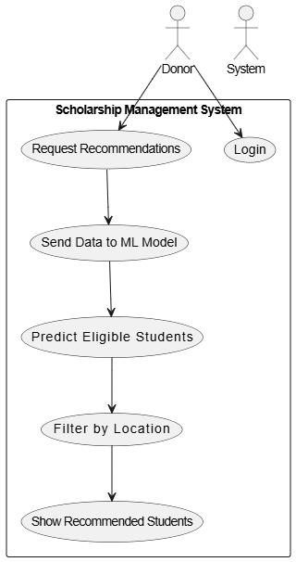
  - Use Case 5
Field | Details
ID | UC005
Name | Verify Applications
Description | This use case describes how an admin verifies scholarship applications by reviewing student details and documents, then approving or rejecting.
Requirement(s) | FR005
Actor(s) | Admin
Precondition | Admin must be logged in.
Postcondition | Application status is updated (approved/rejected) and the student is notified.
Basic Flow
- Admin logs into the system.
- Admin views submitted scholarship applications.
- Admin checks student details.
- Admin verifies uploaded documents.
- Admin approves or rejects the application.
- System updates the application status in the database.
- System notifies the student of the decision.
Alternative Flow
- Admin requests more information/additional documents from the student.
- System sends a notification/request to the student.
- Student provides additional documents, and admin resumes verification.
Exceptions
- E1: Invalid Documents — Admin rejects the application and system updates status accordingly.
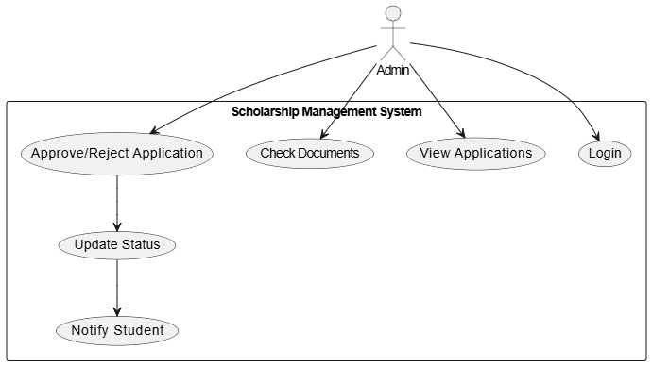
- References
- K. Jain, M. N. Murty, and P. J. Flynn, “Data clustering: A review,” ACM Computing Surveys, vol. 31, no. 3, pp. 264–323, 1999.
- T. Cover and P. Hart, “Nearest neighbor pattern classification,” IEEE Transactions on Information Theory, vol. 13, no. 1, pp. 21–27, 1967.
- I. Witten, E. Frank, M. Hall, and C. Pal, Data Mining: Practical Machine Learning Tools and Techniques, 4th ed. San Francisco, CA, USA: Morgan Kaufmann, 2016.
- S. Russell and P. Norvig, Artificial Intelligence: A Modern Approach, 3rd ed. Upper Saddle River, NJ, USA: Prentice Hall, 2010.
- Django Software Foundation, “Django Web Framework Documentation,” [Online]. Available: https://www.djangoproject.com/⁠
- [6] Scikit-learn Developers, “Scikit-learn: Machine Learning in Python,” [Online]. Available: https://scikit-learn.org/⁠
- [7] R. Pressman and B. Maxim, Software Engineering: A Practitioner’s Approach, 8th ed. New York, NY, USA: McGraw-Hill, 2015.

